Chapter 2, Solution 40

Req = 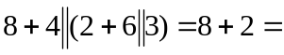10 Ω
I = 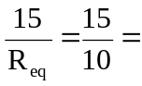 1.5 A

